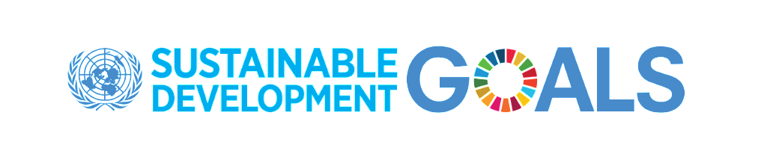UN Announces Global Media Compact to raise awareness of the Sustainable Development Goals
New York, 23 September – The United Nations announced today the launch of the SDG Media Compact, an initiative marking a new drive to advance awareness of the Sustainable Development Goals (SDGs) that were unanimously adopted by all world leaders at the United Nations in 2015. The Compact seeks to inspire media and entertainment companies around the world to leverage their resources and creative talent to advance the Goals.
Speaking at the launch at UN Headquarters on the sidelines of the UN General Assembly on behalf of more than 30 founding media organizations-encompassing more than 100 media and entertainment outlets-Olusola Momoh, Chairwoman, Channels Media Group-Nigeria introduced the Compact to UN Secretary-General António Guterres: “I am proud to present you the SDG Media Compact. We are an alliance of news and entertainment media and we are committing to work with the United Nations to foster public discourse and spur action on the Sustainable Development Goals. We will increase our content on the issues spelled out in the 2030 Agenda and discuss solutions. Where necessary, we will hold Governments to account for the bold promise they have made to their people and to the world.”
Collectively, the founding members of the SDG Media Compact already comprise an audience in the billions spanning over 80 countries on 4 continents and many more companies are expected to join. “Together, we commit to playing our part to achieve the Sustainable Development Goals,” she added.
“Achieving the Goals by 2030 will require concerted actions by everyone. By telling stories, news and entertainment media have a critical role in multiplying messages and propagating new ways of behaving,” said Under-Secretary-General for Global Communications Alison Smale at the launch event. “As major players in fostering the SDG discourse, they are also key in holding governments accountable.”
The SDG Media Compact is inclusive and aims to embrace media companies from all regions and all platforms. Participating organizations will have the opportunity to create content partnerships with the United Nations, whereby the organization will increase its efforts to source and share high-value media content and newsworthy opportunities relating to the SDGs. Regular monitoring and review meetings will gauge engagement.

The Compact is an initiative of the United Nations, in collaboration with the UN Foundation and with the support of FleishmanHillard.
Founding Compact members
Al Jadeed TV-Lebanon, Aljoumhouria Newspaper-Lebanon, Annahar Newspaper-Lebanon, Asahi-Shimbun-Japan, Asia-Pacific Institute for Broadcast Development, Association of Commerical TV in Europe, Association of International Broadcasters, Athina 9.84 Radio station-Greece, Channels Media Group-Nigeria, China Media Group, Daily Star Newspaper-Lebanon, Daily Tribune-Philippines, Deutsche Welle-Germany, Discovery, Inc., Eurasia-Azerbaijan, Eurovision, Kathimerini-Greece, LBCI TV-Lebanon, Lebanon Files News, Ministry of Information and Broadcasting-India, Naharnet News-Lebanon, National Union of Tunisian Journalists-SNJT, Nikkan Kogyo Shimbun-Japan, Nippon TV-Japan, RLL Radio-Lebanon, Sound Diplomacy, Tass-Russia, This Day-Nigeria, TVC-Communications-Nigeria, TV-BRICS-Russia, VDL Radio-Lebanon, Ziff Davis.
About the SDGs
The 17 Sustainable Development Goals were adopted by world leaders at the historic Sustainable Development Summit in September 2015. Encompassing everything from health, to gender equality, and education, the Goals will mobilize efforts around the world to end all forms of poverty, fight inequalities and tackle climate change, while ensuring that no one is left behind.
Media contacts
UN Department of Public Information
Francyne Harrigan, M: +1 (917) 428-7505| E: harriganf@un.org
Dan Shepard, T: +1 (212) 963-9495 | E: shepard@un.org

For more information, please visit: www.un.org/sustainabledevelopment or follow us on Twitter at @GlobalGoalsUN and on Facebook at www.facebook.com/globalgoalsUN.

